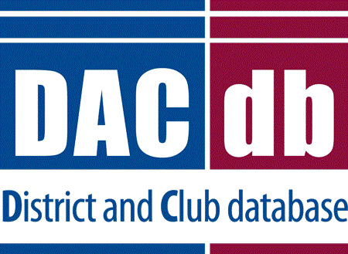 | DACdb Grants Module Club Process

ENTERING YOUR GRANT

- Clubs should designate the contact (also known as preparer) for the grant. You can have more than one contact.
- Clubs should add those who will be the signers of the grant. Check on your club’s requirements as to how many signatures you will need.
- Log into the District Database (if you are higher than a level 4, make sure to use your club number when logging in.)
- Click on the My Club Tab

- Then Click on the Grants Icon

- Click on the Club Grants View on the left side menu

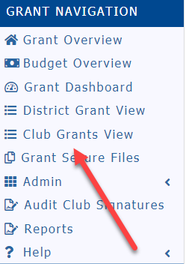
- Change Org Year to the year you are applying for.

- Once the correct year is selected, click on New Club Grant Request

- There are four pages to complete on the New Grant Request
  - Details
  - Clubs Involved
  - Contacts
  - Application

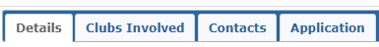

- Details
  - This page contains general information about the grant. Fill the page out completely.

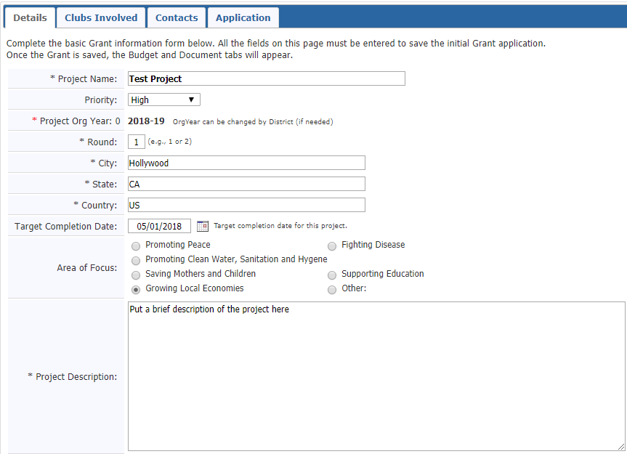

- Clubs Involved
  - Your club name will automatically appear here. If another club is working on the grant, select them from the list on left and use the arrows to move them to the right.

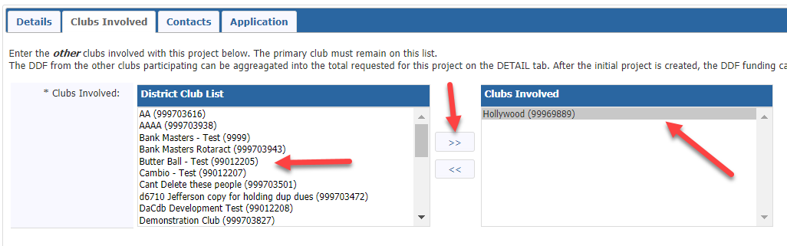

- Contacts
  - This is a list of the club members who will be working on preparing the grant and are responsible for collecting receipts, money, closure, etc. The person’s name who started the process of the application will automatically appear on the right. To add others select them from the left column and move them over with the right arrows. Keep in mind, automated emails will be sent out and if “Contacts” is selected as recipients all the individuals listed will receive the same email.

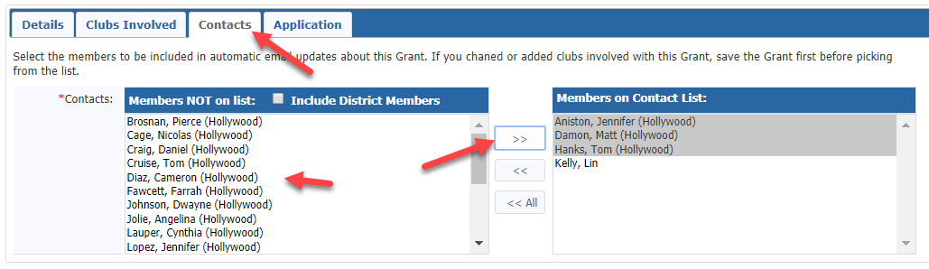

- Application
  - This page is the application itself. Some of this information is automatically transferred to the Final Report so watch your spelling and be very detailed here. 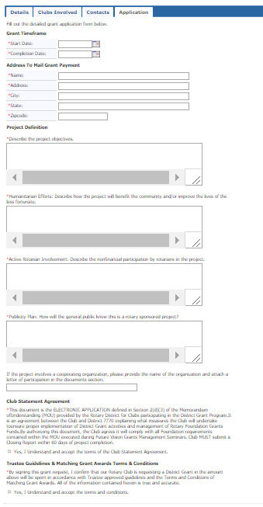

- Once you have completed all four tabs, click on Save – You now have a draft grant

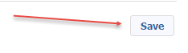

- Once you click on “save”, two new tabs will now appear on the top of the page, Budget & Documents.

- Add your Income Items. Click on Add Income Source
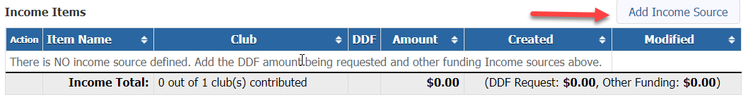
- A pop-up box will appear
- Enter Description
- Once you put DDF Requested Amount or Requested DDF amount put the amount in and make sure you select the Funding Source. So in this case you will select DDF Requested.
- If your District requires our club to spend an amount equal to your request, enter that amount as additional income enter those items but for the Funding Source click on Other Club Funding

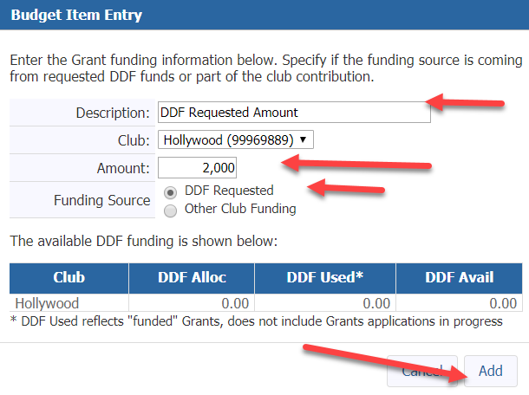

- Once you have your income added it will look something like this:
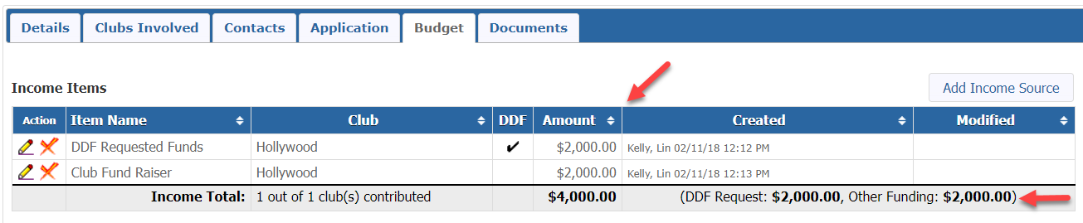

- Expenditures should be itemized and include any estimated expenses for the project.
- Click on Add Expense
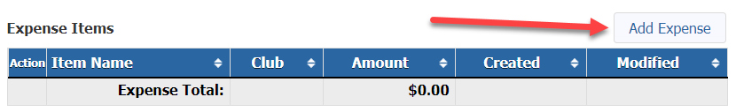
- Enter your description and amount, click on Add

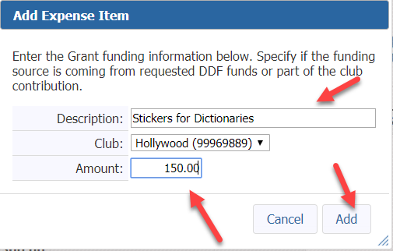
- Continue to add your estimated expenses until expenses equal income sources.
- So, your budget should look something like this
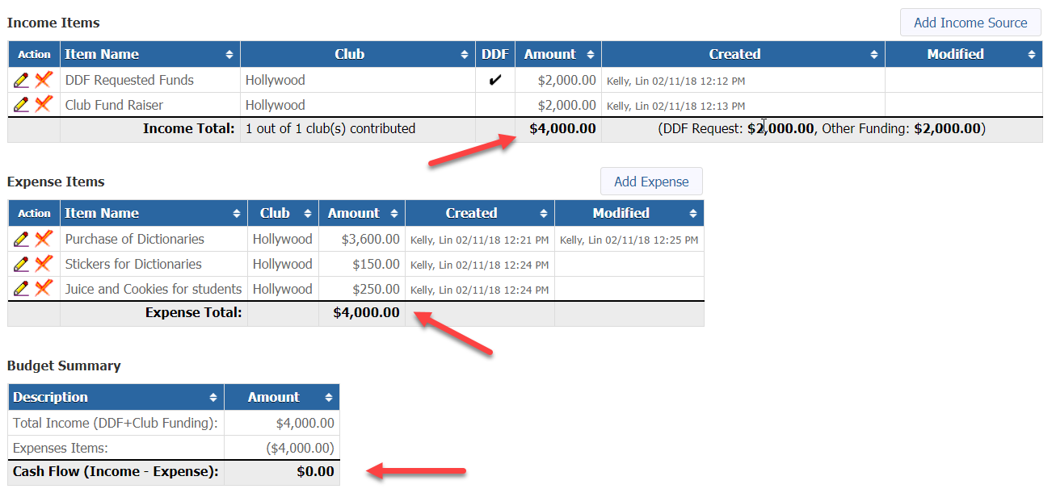

- If you have any letters of commitments, copies of quotes and other documentation, please upload them under the Document Tab. Signed MOU’s can also be uploaded here.

- Click on the Documents Tab

- Add documents by clicking on the upload file or add a folder and then upload files in the folder.
- You can also use the existing folders Documents and Images if you wish.
- To have the best results for the Final Report, upload your receipts and images as jpg or png.
- You can also add pdfs, excel, and word documents.
- When you name files please do not put in any special characters or you could incur a problem with opening the file.
- Also note the Grant Application is saved as an html file as your work through the process.

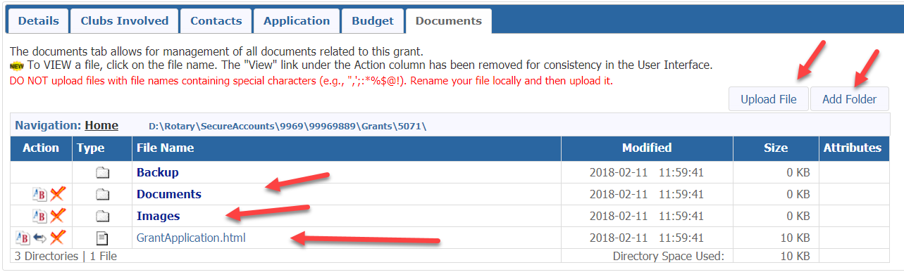

- Browse your computer for the file and click on add. Do not use any type of special characters or punctuation in the naming of your documents.

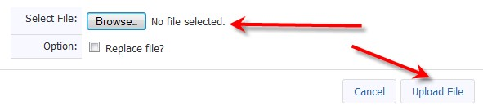

- At this point, SAVE your grant. You can never save too often!

- Once you complete your budget and add documents you will see two additional tabs – “Activity Log” and “Signatures.
- You can click on “Activity Log” to see what has been completed and “Signatures” to see where you are in the signing process. Once your grant is approved you will see the “Interim Report and the “Final Report” tabs. In most cases Districts do not require an Interim Report. Your District will advise you. The “Final Report” button will be used when you complete your project.

- Double check all your work before you collect the club signatures. You can always delete the grant at this point.

SIGNING & SUBMITTING A GRANT

- The District designates how many signatures from each club are needed. In this example, we are going to use two signatures required. If other clubs are involved with your grant, you need two signatures from each club.
- The signers must be on the club signature list. Probably the President of your club will click on Admin on left menu bar and then Club Signatures. Select the individuals from the left column and move them over to the right column. Then click on save.

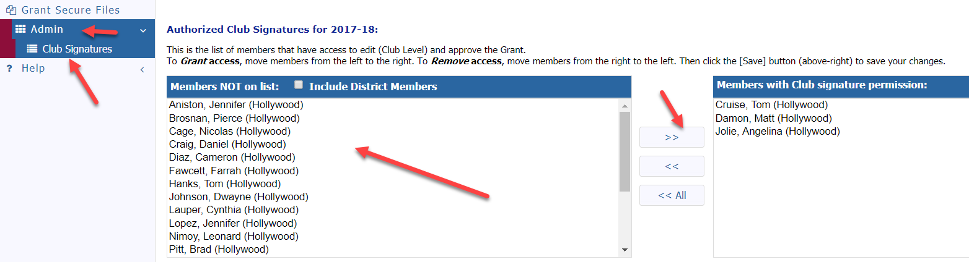

- Signer number one will click on edit grant (the pencil)

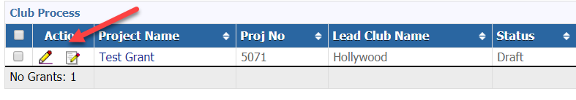

- He/she will click on “Club: Collect Club Signatures”

- The following message will appear

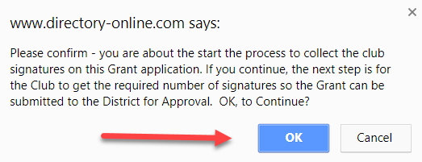

- He/she will click OK. Two new buttons appear on the top right. “Club: Sign Grant Application” and “Revert to Draft”.

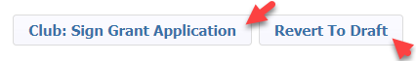

- Signer number one will now click on “Club: Sign Grant Application”.

- A new box pops up – they will click on sign grant

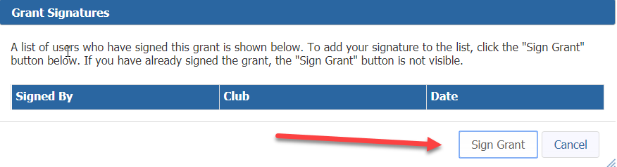

- The second signer is now ready to sign the grant application.
- Click on the edit pencil in front of the grant
- Click on “Club: Sign Grant Application” on top right
- The signature box will pop up, they will see the first signer’s name in the box. They now will click on “Sign Grant”

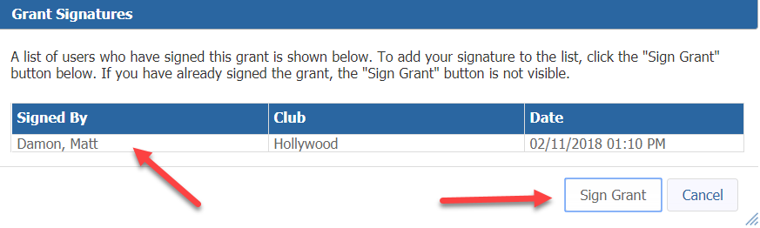

- The second signer will now click on the button “Submit Grant for District Approval”

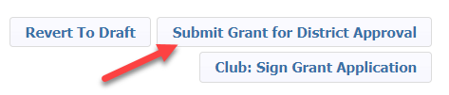

- The status of the grant will now say “Submitted Grant for District Approval

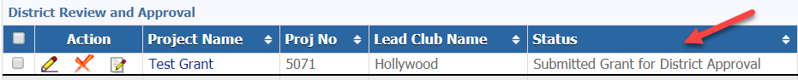

- The District will now review the grant. You can no longer make any edits to the application. However, you can add additional documents to the grant and add information to the expense tab. You can also “revert back to draft” if you need to start over.
- If the District requires more information, you will receive a note from the District Grant Chair.

